**Using SQL with temporary tables**

1) When are temporary tables automatically deleted?

After running a query in your SQL database

After ending the session in a SQL database

After completing all calculations in the table

After running a report from the table

**Correct**

Temporary tables are automatically deleted after ending the session in a SQL database.

### 2.The following SQL query contains information about bike trips:

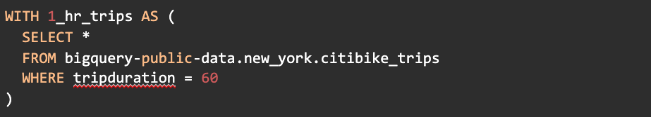WITH 1_hr_trips AS ( SELECT * FROM bigquery-public-data.new_york.citibike_trips WHERE tripduration = 60

What data will appear in the temporary table created through this query?

Bike trips equal to or more than one hour

**Bike trips that lasted exactly 60 minutes**

The total number of bike trips

A random subset of bike trips

**Correct**

This temporary table will show bike trips that lasted exactly 60 minutes. The name of the table is “1_hr_trips” and the query includes the condition that trips in the table equal one hour.

### 3.What benefit does a CREATE TABLE statement add to a temporary table?

**Access for anyone to use the table**

Automated calculations

Specific naming conventions

Metadata about the data in the table

**Correct**

A CREATE TABLE statement provides access for anyone to use the temporary table. The SELECT INTO statement is better suited for one person.